|  |  |  |  |
| --- | --- | --- | --- |
| 2 | | 58,087 | |
| **NUMERO DE FRONTERAS** | | **ENERGIA AGREGADA** | |
|  | | | |
| 225,638,853 | 129 | | 9,183,316 |
| INGRESO 2020 | DÍAS CERTIFICADOS 2020 | | ENERGIA RESPALDADA 2020 |
|  | | | |
| 36,992,581 | 23 | | 1,646,976 |
| INGRESO 2021 | DÍAS CERTIFICADOS 2021 | | ENERGIA RESPALDADA 2021 |

**HISTORICO REINTEGRO DDV**

|  |  |  |
| --- | --- | --- |
|  | **2020** | **2021** |
| **ENE** | - | 32.44 |
| **FEB** | - | 4.56 |
| **MAR** | - | - |
| **ABR** | 13.12 | - |
| **MAY** | 2.1 | - |
| **JUN** | 4.38 | - |
| **JUL** | 23.75 | - |
| **AGO** | 33.61 | - |
| **SEP** | - | - |
| **OCT** | 66.4 | - |
| **NOV** | 23.53 | - |
| **DIC** | 58.76 | - |

**Los valores de la tabla están en millones de COP**



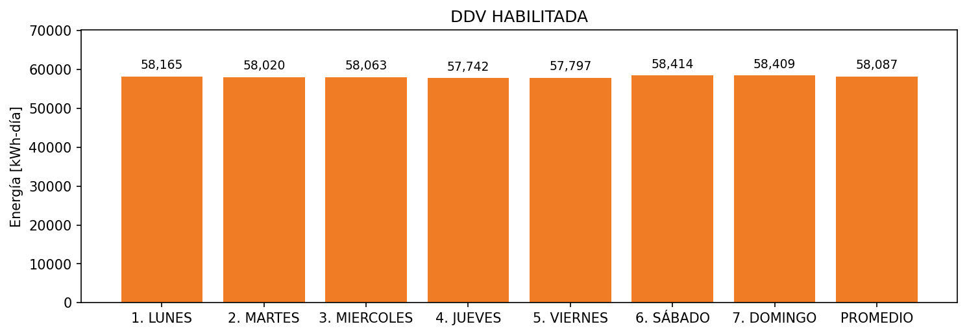

|  |  |  |  |  |  |  |  |  |  |
| --- | --- | --- | --- | --- | --- | --- | --- | --- | --- |
| **FRONTERA** | **COD SIC** | **FRT DDV** | **TIPO DDV** | **PROMEDIO** | **PRÓXIMA ACTUALIZACIÓN** | **MARGEN DE ERROR** | **ÚLTIMA PRUEBA DDV** | **DÍAS PARTICIPACIÓN** | **FECHA REFERENCIA PRÓXIMA PRUEBA DDV** |
| VIDRIO ANDINO S.A | Frt19786 | Frt36478 | LBC | 58,087 | 2022-03-08 | 4,29 | 2020-09-17 | 87.0 | 2021-12-18 |
| VIDRIO ANDINO S.A | Frt19785 | Frt36479 | LBC | 0 | 2022-03-09 | 3,67 | 2020-11-09 | 67.0 | 2022-01-15 |